Bucharest Inside the Beltway Annual Report 2015 January 1, 2016
for the Board, Donors and all Interested Parties

Dear supporter of Bucharest Inside the Beltway (BiB),

We hope that everyone from Romania to DC and around the world had a most Happy Holidays! BiB is delighted to report that we celebrated our 2 year birthday on Dec. 4 in DC, reflecting on an excellent two years and meditating on our unanticipated successes with gratitude and much hope and excitement for the future! Please check out all of our photos documenting our artistic projects on BiB’s website, Facebook, Twitter and Instagram …. Happy New Year!

This past March BiB Executive Director Cristina Bejan was invited by Philip Arnoult (Center for International Theatre Development) to be part of an American delegation of theatre company directors (that included Mosaic’s Ari Roth and Woolly Mammoth’s Howard Shalwitz) to witness the DunaPart theatre festival in Budapest, Hungary. Meeting Ari Roth in Budapest has opened up further opportunities for BiB: starting in September 2015 Mosaic Theater Company of DC and BiB are engaged in promotional and programmatic partnerships.

BiB’s full production for 2015 was “Finally Quiet In My Head,” which was accepted to the DC Black Theatre Festival (DCBTF) for its US premiere. Bejan was one of the festival’s eight featured playwrights and the play performed to packed houses at Anacostia Arts Center. The play promoted NAMI, the National Alliance for the Mentally Ill, and BiB hosted a talk-back with NAMI representatives after the final performance. The play was reviewed favorably in DC’s theatre press. At DCBTF we shared the theatre with Jackie Brown’s original play A Conversation with the Man Who Killed My Son and since then we are honored to promote Brown’s show via BiB’s networks.

Just following DCBTF BiB promoted three BiB artist shows in the Capital Fringe Festival: Star Johnson’s How to Quit Your Day Job, Hope Villanueva’s Crane Fable and Ruthie Rado’s War and Peas. How to Quit Your Day Job not only SOLD OUT its extended run at the festival, the show won the Best Musical award at the Capital Fringe equivalent of the Oscars. In the midst of Fringe promotion, BiB produced a Romanian cultural event: hosting dancer Paul Cosma Cimpoieru for a performance at the Goethe Institut on June 26.

In September our production of Finally Quiet In My Head was invited to perform as a live reading in the Russian Lounge of the Kennedy Center Opera House, as part of the Page to Stage Festival. The show played again to a full house and we hosted another talk-back promoting NAMI. We are honored that this talk-back featured the Executive Director of NAMI DC Krystal Wortham.

Later that month the TV pilot of DISTRICTLAND (BiB, Capital Fringe 2014) was shot at locations across DC. The pilot will be first screened at the DC Independent Film Festival on March 4 at 7pm at National Community Church (Barracks Row Campus, 535 8th St. SE DC 20003). From the original cast, Robyn Freeman and Vick Krishna reprise their roles in the TV series. The show has already received a stand-out feature article in the Washington Post.

BiB directors Rucsandra Pop and Cristina Bejan met in October in Bucharest to debrief and further plan. Pop celebrated a play in the Sibiu Fringe Festival this past summer and continues to keep BiB’s presence alive back in Bucharest in a plethora of ongoing cultural projects, including her play Talk to the Bomb that is currently showing to SOLD OUT audiences at Godot Theatre.

The first year BiB functioned on private individual donations and we raised the money crowd-funding on Indiegogo. Our second year we are delighted to report that we raised money through private donations collected at our DCBTF performances (approximate total: $500) and we received our first grant: $10,000 from the Riordan Foundation, an educational charity located in Los Angeles. Our operating budget for 2015 was $10,500 and we spent $10,483. Our second year we have again been able to pay our artists a very competitive fee for their work. Going forward we intend to apply for further grants and have another crowd-funding campaign as BiB continues to establish itself as a DC arts collective that operates at the highest professional standards.

BiB has much to look forward to in 2016. LADY GODIVA will appear as a Work in Progress in the Source Theatre rehearsal room on February 8 at 7.30 pm as part of the Mead Theatre Lab program. The show, written by Cristina Bejan, will be directed by Star Johnson, performed by Muslima Musawwir and will be promoting RAINN: the Rape Abuse and Incest National Network. All proceeds from the showcase will go to RAINN and we will have a talk-back with survivors from the RAINN Speakers Bureau following the performance.

Further BiB events to look forward to in 2016 include hosting Russian dancer and pianist Anya Yermakova, collaborating on a cultural event with the Romanian Embassy, promoting BiB artist shows in the Capital Fringe Festival and the DC Black Theatre Festival, participating again in the Kennedy Center’s Page to Stage Festival, promoting ongoing performances in Romania and exploring further artistic opportunities in Washington DC.

Thank you for all your support over the past two years! This year BiB was most fortunate to be accepted by the NYC charity Fractured Atlas and we can now accept tax-deductible donations:

Please Donate Here!

Remember if you would like to get involved artistically with BiB – let us know! Our motto remains: Building a home for every unheard voice in the District of Columbia and beyond!

All good things in 2016! And thank you.
Cristina Bejan
BiB Executive Director
bucharestinsidethebeltway@gmail.com

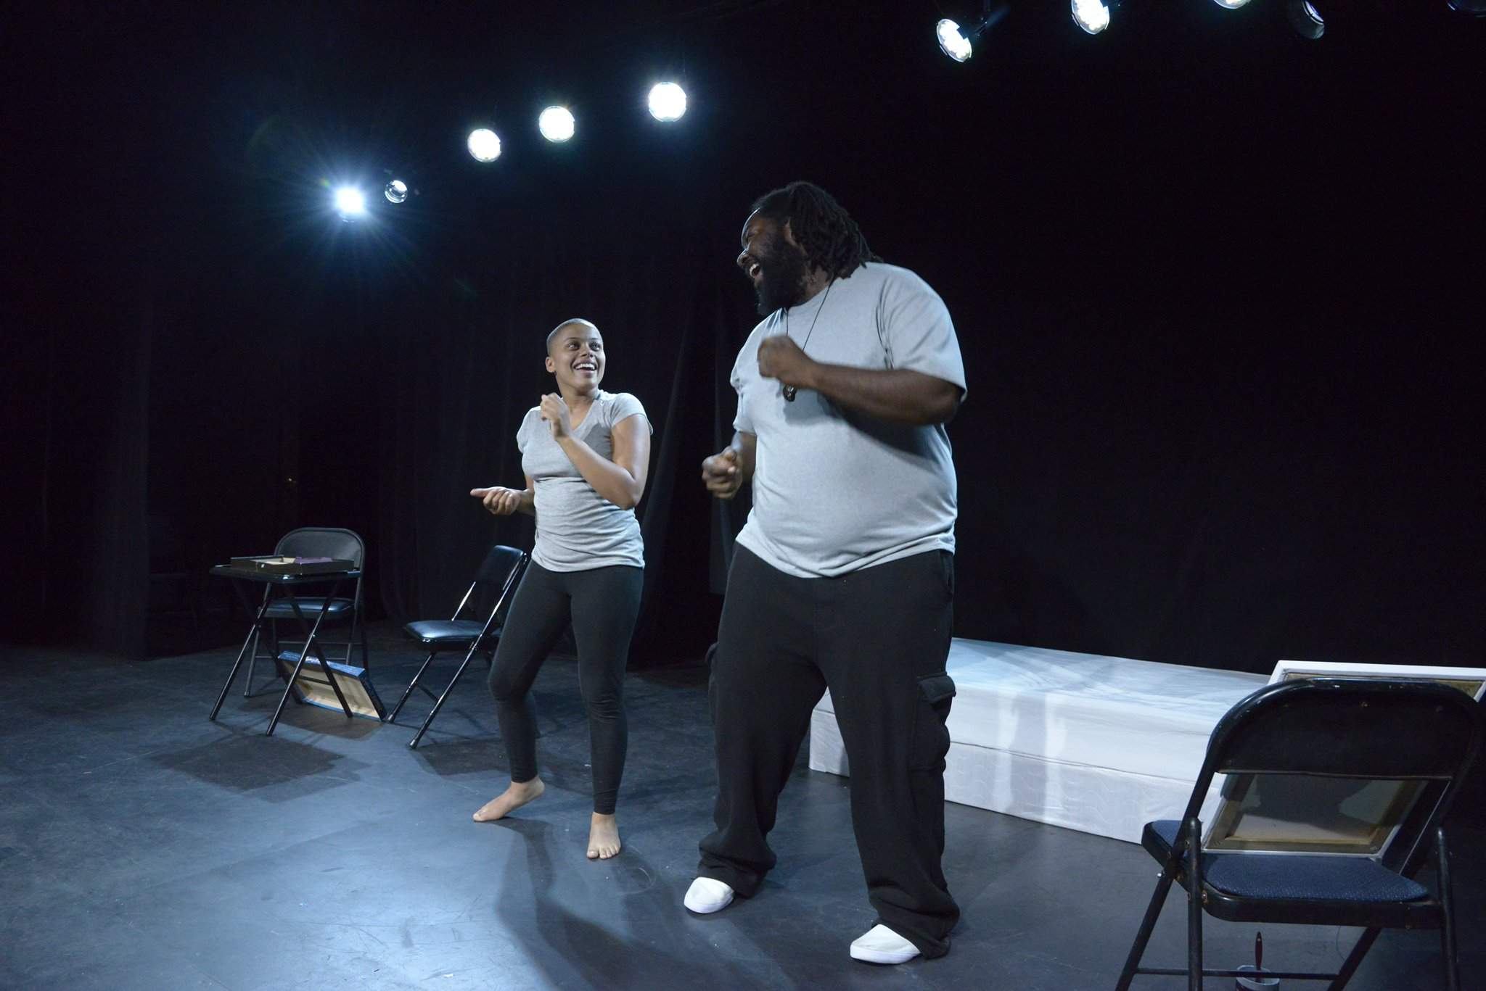
Morgan (Muslima Musawwir) and Gerard (Christopher Akinbuwa) have a dance-off at St. Elizabeths Hospital in Finally Quiet In My Head June 21, 2015 as part of the DC Black Theatre Festival.

